

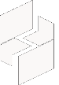

MICROSOFT ARCHITECTURE BEST PRACTICE FOR AI BUSINESS PROCESS
USECASE: CUSTOM DOCUMENT PROCESSING

Document Title | Microsoft Cloud Center of Excellence Overview
Presales/Technical Head | Tushar Mehrotra/Rohit Pandey
CCoE Lead | Ravishankar N
Creation Date | 11th February 2026
Version | Description | Modified by | Date | Approved by | Date
1 | Draft architecture baseline for review | Sharmila Devi K | 04/02/2026 | Ravi Shankar | 04/02/2026
2 | Updated draft with architecture refinements and review comments | Sharmila Devi K | 09/02/2026 | Ravi Shankar | 09/02/2026
3 | Final approved architecture design | Sharmila Devi K | 11/02/2026 | Ravi Shankar | 11/02/2026
Contents

1. Executive Summary 3
2. Scope and Applicability 3
3. Business Scenario Overview 3
4. Reference Architecture Overview 4
4.1 Architecture Description 4
5. Logical Architecture Components 4
5.1 Ingestion and Orchestration Layer 4
5.2 Data Storage Layer 5
5.3 Model Development and Training Layer 5
5.4 Model Registry and Lifecycle Management 5
5.5 Deployment and Inferencing Layer 5
6. Architectural Best Practices 6
6.1 Azure Well-Architected Framework Alignment 6
6.2 Governance & MLOps 6
6.3 Security and Responsible AI 6
7. Cloud Center of Excellence Enablement Model 7
8. Reusability and Scalability 7
9. Conclusion 7

Custom Document Processing

Executive Summary
This document defines the standardized reference architecture and architectural best practices governed by the Cloud Center of Excellence (CoE) for building, training, deploying, and operating custom AI/ML models on Microsoft Azure.
The reference architecture is based on the Microsoft Azure Architecture Center guidance for custom model lifecycle management, including ingestion, training, registry, deployment, and inferencing using Azure AI and Machine Learning services.
This document serves as audit-ready evidence demonstrating Cloud Center of Excellence capability, fulfilling Frontier Distributor checklist Section 3.1.1 requirements.

Scope and Applicability
This reference architecture applies to:
- CSP distributors and reseller enablement models
- AI/ML workloads requiring custom models
- Document processing, NLP, computer vision, and predictive analytics
- Real-time and batch inferencing use cases
- SMB, Mid-Market, and Enterprise customer environments
The architecture supports repeatable deployments across geographies, enabling consistent Cloud CoE governance for global CSP operations.

Business Scenario Overview
Prebuilt AI models are not always sufficient for domain-specific requirements. Organizations often need to:
- Train custom models using proprietary data
- Extract structured insights from unstructured documents
- Apply custom NLP, classification, or computer-vision logic
- Deploy models securely at scale
Azure enables an end-to-end custom model lifecycle, from ingestion and labeling to deployment and inferencing, using managed services.

Reference Architecture Overview

4.1 Architecture Description
The solution implements a modular AI/ML lifecycle architecture, where:
- Data is ingested from multiple sources
- Training datasets are curated and labeled
- Custom models are trained using Azure AI or Machine Learning services
- Models are registered and versioned
- Deployed models are consumed via REST APIs or SDKs
This pattern enables governed, scalable, and reusable AI workloads.
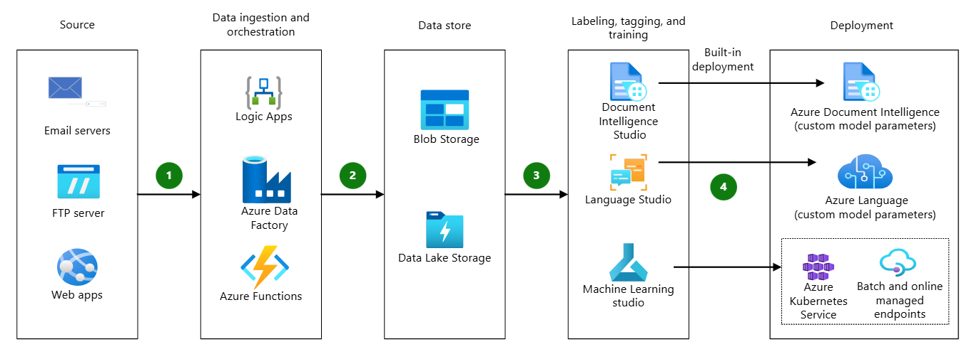

Logical Architecture Components

5.1 Ingestion and Orchestration Layer
Azure Logic Apps / Azure Functions / Azure Data Factory
- Orchestrate ingestion of files, messages, and attachments
- Support event-driven and batch workloads
- Enable serverless and managed execution models

5.2 Data Storage Layer
Azure Blob / Azure Data Lake Storage Gen2
- Stores raw training data and documents
- Organizes data by attributes (file type, customer, scenario)
- Acts as the system of record for model training inputs

5.3 Model Development and Training Layer
Azure supports multiple custom model development paths, depending on use case:
- Azure AI Document Intelligence Studio – custom document extraction models
- Azure AI Language Studio – text classification and NER models
- Azure Machine Learning – advanced ML workflows (PyTorch, TensorFlow, Scikit-learn)
- Azure OpenAI (Foundry Models) – fine-tuned and custom language models
These services provide integrated tooling for labeling, training, and evaluation.

5.4 Model Registry and Lifecycle Management
Azure Machine Learning Model Registry
- Centralized model versioning and metadata
- Tracks training metrics and lineage
- Supports governance and controlled promotions
Model registration is a foundational best practice for repeatable and auditable AI deployments.

Deployment and Inferencing Layer
Managed Online Endpoints / Batch Endpoints
- Real-time inferencing via REST APIs
- Batch scoring for large data volumes
- Supports autoscaling and traffic splitting
Azure Kubernetes Service (AKS) (Optional)
- For advanced or high-throughput scenarios
- Enables custom deployment and scaling strategies
Azure supports multiple deployment targets aligned with performance, cost, and governance requirements.

Architectural Best Practices

6.1 Azure Well-Architected Framework Alignment
Pillar | Implementation Approach
Reliability | Managed endpoints and resilient services
Security | RBAC, managed identities, private networking
Performance | Autoscaling compute and optimized inferencing
Cost Optimization | Serverless and batch deployment options
Operational Excellence | MLOps pipelines and monitoring
These practices align with Microsoft’s AI workload guidance in the Azure Architecture Center.

6.2 Governance & MLOps
- Version-controlled training and deployment pipelines
- Environment separation (dev/test/prod)
- Automated model promotion policies
- Centralized monitoring and logging
Governed MLOps ensures auditability and operational consistency.

6.3 Security and Responsible AI
- Secure access to training data
- Controlled access to model endpoints
- Encryption at rest and in transit
- Monitoring of model outputs and bias
Azure services support Responsible AI principles through controlled and transparent model lifecycle management.

Cloud Center of Excellence Enablement Model
The Cloud Center of Excellence:
- Defines approved AI/ML reference architectures
- Governs model lifecycle standards and best practices
- Maintains reusable pipelines and templates
- Enables resellers through documented guidance
- Ensures consistency across regions and customers
This model satisfies the Cloud Center of Excellence mandate in Frontier Distributor checklist Section 3.1.1.

Reusability and Scalability
This reference architecture:
- Supports multiple AI scenarios and industries
- Scales from SMB workloads to enterprise platforms
- Enables through-channel and co-delivery models
- Promotes reuse across regional deployments

Conclusion
This Cloud Center of Excellence reference architecture provides a Microsoft-aligned, audit-ready, and repeatable framework for building and deploying custom AI/ML models on Azure. It enables distributors to support reseller-led AI solutions while maintaining governance, security, and operational excellence across the partner ecosystem.

